Flight Explorer - CS612 HW3 Documentation

**1. Introduction**

This document provides the necessary details for testing and understanding the **Flight Explorer** website, developed as part of CS612 Assignment #3. The website allows users to explore global flight data, including airlines, airports, and routes. It retrieves data from a PostgreSQL database via a Node.js/Express API and integrates real-time weather information from an external API. The user interface is built with HTML, Tailwind CSS, and Vanilla JavaScript, featuring interactive map visualizations using Leaflet.js.

**Development Environment Note:** This project was developed and tested entirely on a **local machine** (local host). Attempts to deploy and configure the necessary environment on AWS EC2 were unsuccessful due to AWS account suspension. Therefore, all testing instructions assume a local setup.

**2. Setup and Running Instructions**

**2.1. Prerequisites**

* **Node.js and npm:** Must be installed on the testing machine
* **PostgreSQL:** A running PostgreSQL server instance is required.
* **Database Setup:**
  + The required database (default: CS612_HW) must exist on the PostgreSQL server.
  + The five tables (countries, airlines, airports, planes, routes) must be created within that database.
  + The tables must be populated with the necessary data.

**2.2. Database Configuration (Using .env File) - IMPORTANT!**

The application connects to the PostgreSQL database using credentials specified in a .env file located in the project's root directory.

**Instructions for the Tester:**

1. Locate the file named .env.example in the project directory.
2. Make a copy of .env.example and rename the copy to .env.
3. Open the newly created .env file with a text editor.
4. Fill in credentials to match your PostgreSQL setup:
   * PG_HOST: Hostname or IP address (usually localhost)
   * PG_USER: Your PostgreSQL username
   * PG_PASSWORD: Your PostgreSQL password
   * PG_DATABASE: Database name (e.g., CS612_HW)
   * PG_PORT: Port number (default 5432)
   * **Example .env file content:**

PG_HOST=localhost

PG_USER=instructor_pg_user

PG_PASSWORD=instructor_secret_password

PG_DATABASE=cs612_db

PG_PORT=5432

1. **Save** the .env file.

**2.3. Installation and Execution**

1. **Decompress:** Unzip the submitted CS612_HW3_Teja_Kusireddy.zip file into a directory.
2. **Navigate:** Open a terminal or command prompt and navigate into the extracted directory.
3. **Install Dependencies:** Run the command: npm install

This will install Express, pg, Axios, and dotenv.

1. **Configure Database:** Ensure you have created and populated the .**env**file with your correct database credentials as described in Section 2.2.
2. **Start the Server:** Run the command: **npm start** - The server will attempt to connect to the database using the credentials from the .env file. You should see console messages indicating the database connection status and that the API is running (e.g. Database connection successful, Flight Explorer API running at http://localhost:8001). If there are database connection errors, review the error message in the console and double-check the .env file contents and your PostgreSQL server status.
3. **Access the Website:** Open a web browser and navigate to **http://localhost:8001**.

**3. Using the Website**

1. **Homepage:** The application loads displaying the hero section, search form, and an empty map.  
   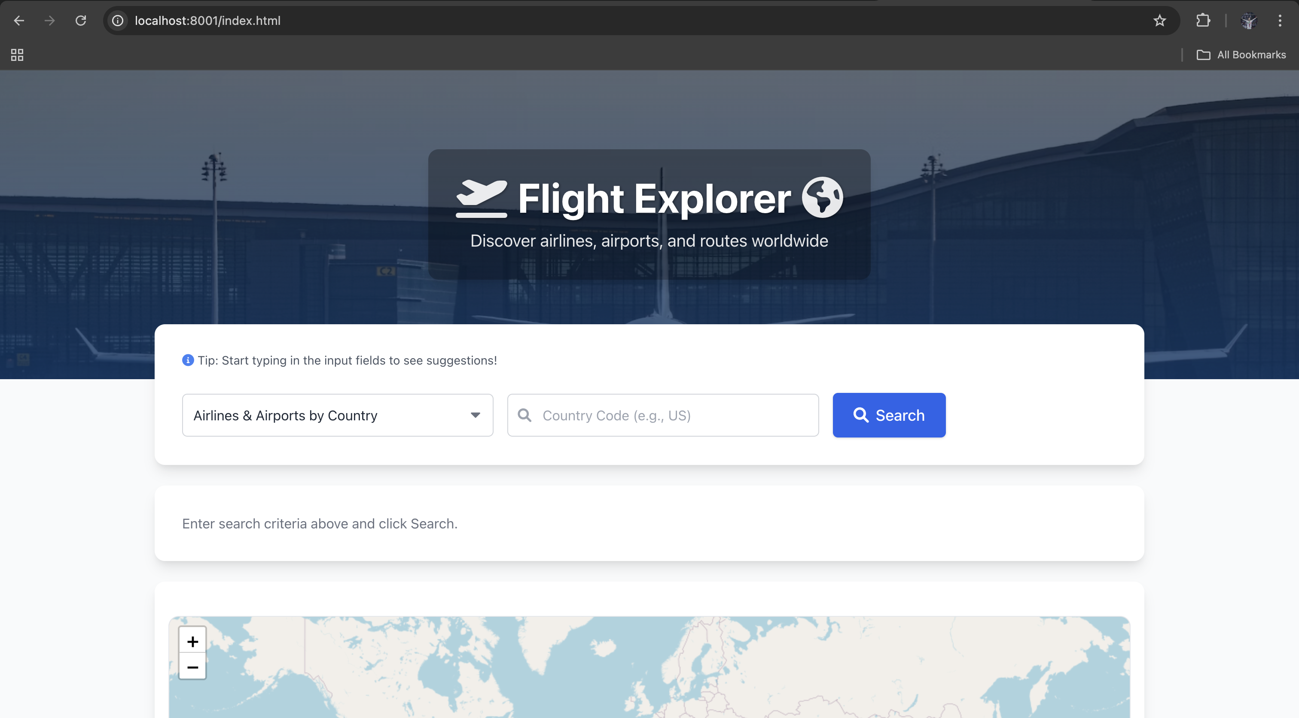
2. **Select Search Type:** Use the first dropdown menu to choose the desired search operation.
3. **Enter Codes:** Enter the required code(s) in the input field(s). Use the dynamic placeholder text as a guide. Start typing to see **autocomplete suggestions** below the input field. Click a suggestion to select it.  
   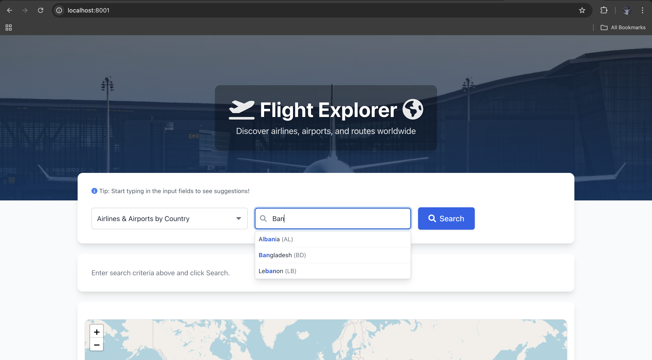
4. **Search:** Click the "Search" button.
5. **View Results:** A loading indicator appears briefly. Results are displayed below the search form (as lists, tables, or detailed text).
6. **View Map:** The map at the bottom updates to show relevant airport markers (clickable for details) and route lines (if applicable). The map auto-zooms to fit the data.  
   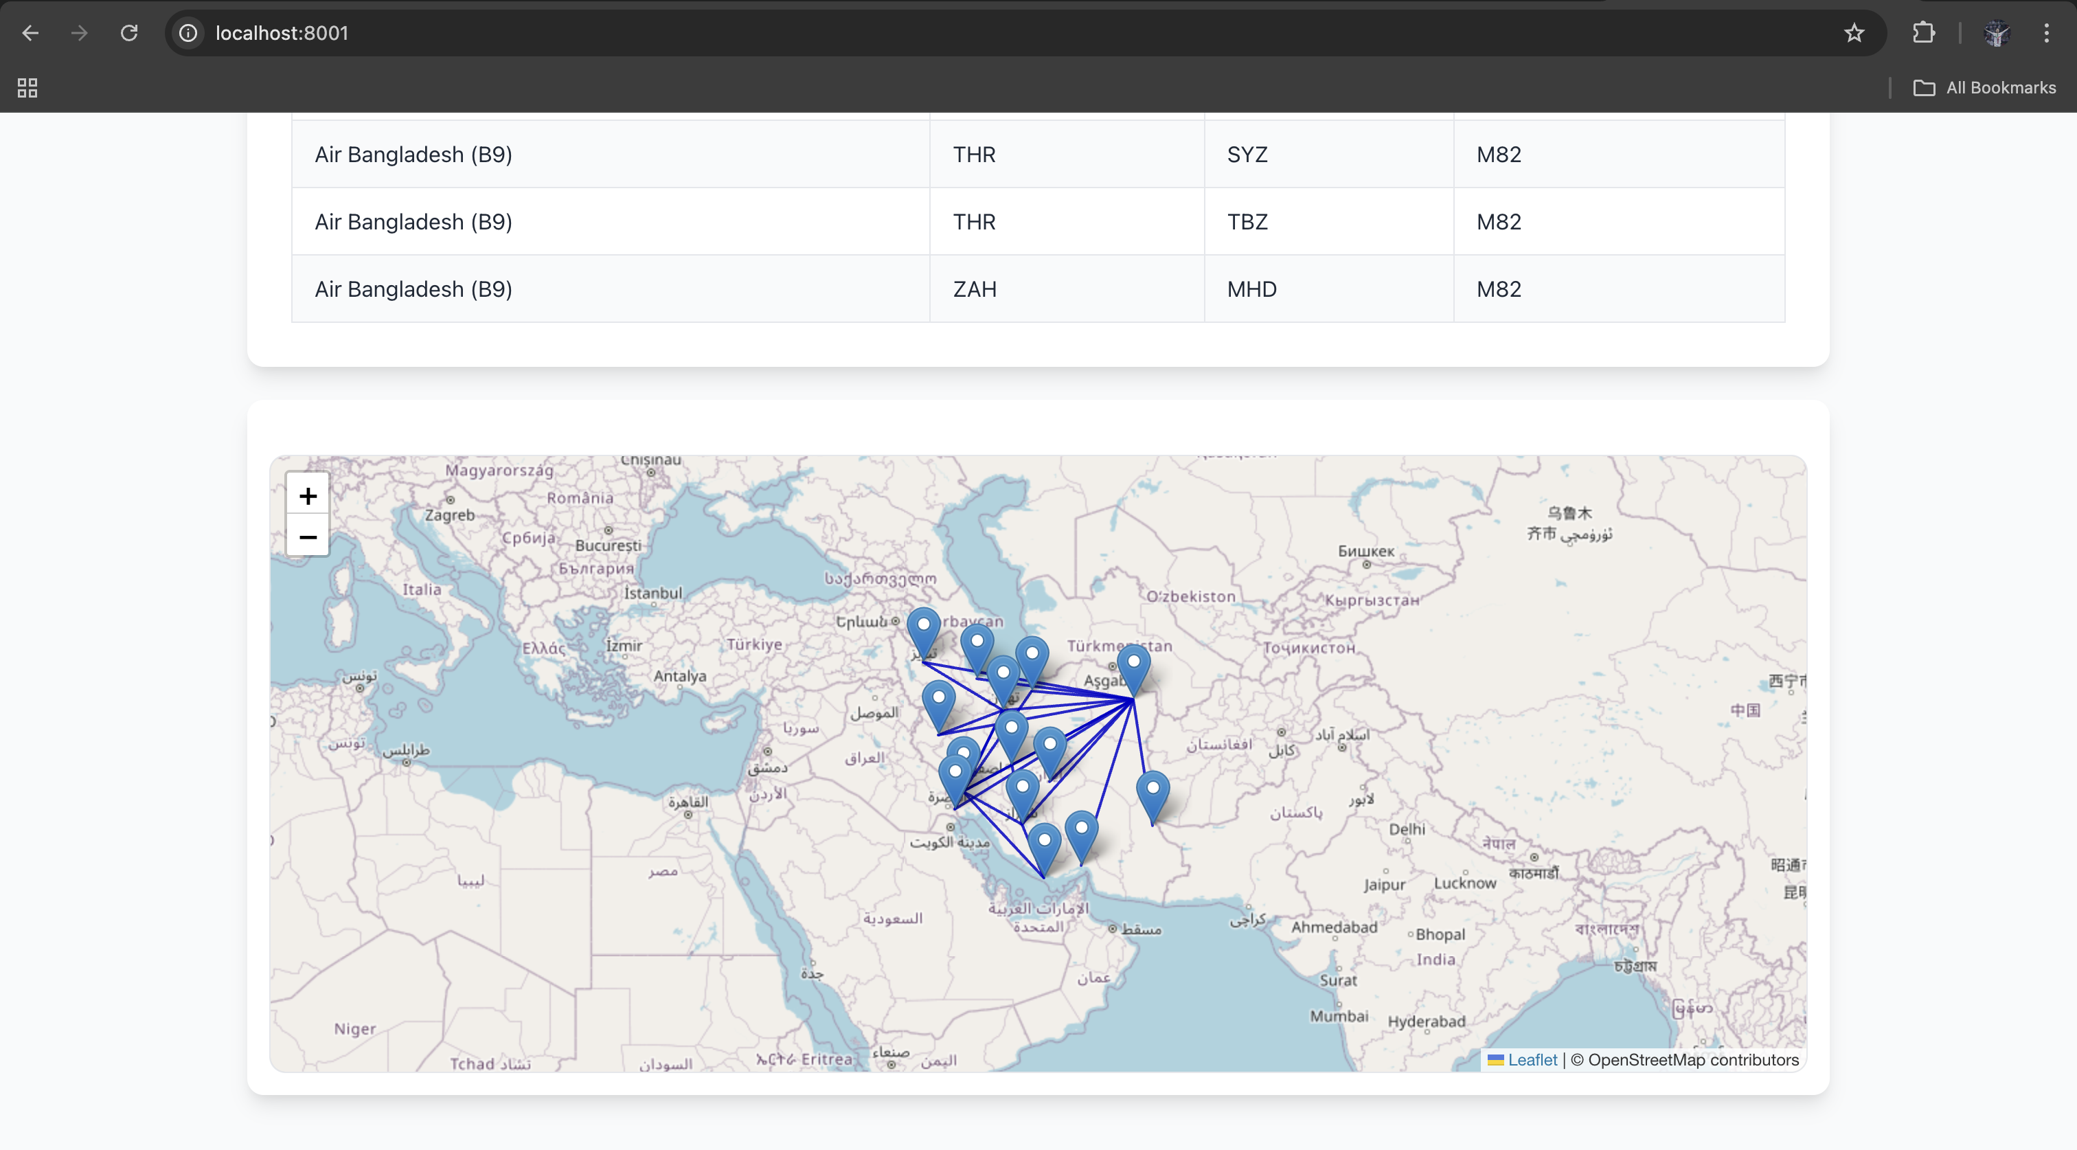

**Repeat:** Select a new search type or enter new codes and click Search to explore further.

**4. Implemented Features**

**4.1. Mandatory Requirements Checklist**

All mandatory features listed in Exercise 1 of the assignment description have been implemented:

* [✓] Select Country ➔ View Airlines & Airports.
* [✓] Select Airline ➔ View Routes/Airports.
* [✓] Select Airport ➔ View Airport Details (Name, Codes, City, Country, Weather).
* [✓] Select Airport ➔ View Routes Originating From.
* [✓] Select Airport ➔ View Routes Arriving At.
* [✓] Select Airport ➔ View Airlines Flying To/From.
* [✓] Select Airport Pair ➔ View Airlines Flying Between.
* [✓] Select Airport Pair ➔ View Distance Between.

**4.2. Verifying Mandatory Requirements (Instructor Guide)**

This section provides examples for testing each mandatory requirement.

1. **Select Country ➔ View Airlines & Airports**
   * **Test:** Select "Airlines & Airports by Country", enter **IN**, click Search.
   * **Expected:** Heading "Results for India (IN)"; List of Indian airlines (e.g., Air India (AI)); List of Indian airports (e.g., Indira Gandhi Intl (DEL)); Map shows Indian airports.
2. **Select Airline ➔ View Routes/Airports**
   * **Test:** Select "Routes by Airline", enter  **EK**, click Search.
   * **Expected:** Table "Routes for Airline EK" (Emirates); Map shows airports on EK routes and the route lines.
3. **Select Airport ➔ View Airport Details (Name, Codes, City, Country, Weather)**
   * **Test:** Select "Airport Details", enter **JFK**, click Search.
   * **Expected:** Details for John F Kennedy Intl (JFK), including codes, location, and current weather; Map zooms to JFK marker.  
     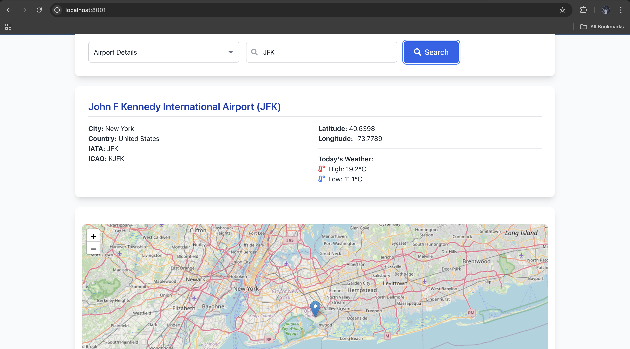
4. **Select Airport ➔ View Routes Originating From**
   * **Test:** Select "Routes From Airport", enter **HYD**, click Search.
   * **Expected:** Table "Routes Departing from HYD"; Map shows HYD and destinations, with lines originating from HYD.
5. **Select Airport ➔ View Routes Arriving At**
   * **Test:** Select "Routes To Airport", enter **BOM**, click Search.
   * **Expected:** Table "Routes Arriving at BOM"; Map shows BOM and origin airports, with lines arriving at FRA.
6. **Select Airport ➔ View Airlines Flying To/From**
   * **Test:** Select "Airlines To/From Airport", enter **CDG**, click Search.
   * **Expected:** List "Airlines Flying To/From CDG" (e.g., showing "Air France (AF)", etc.); Map shows CDG marker.  
     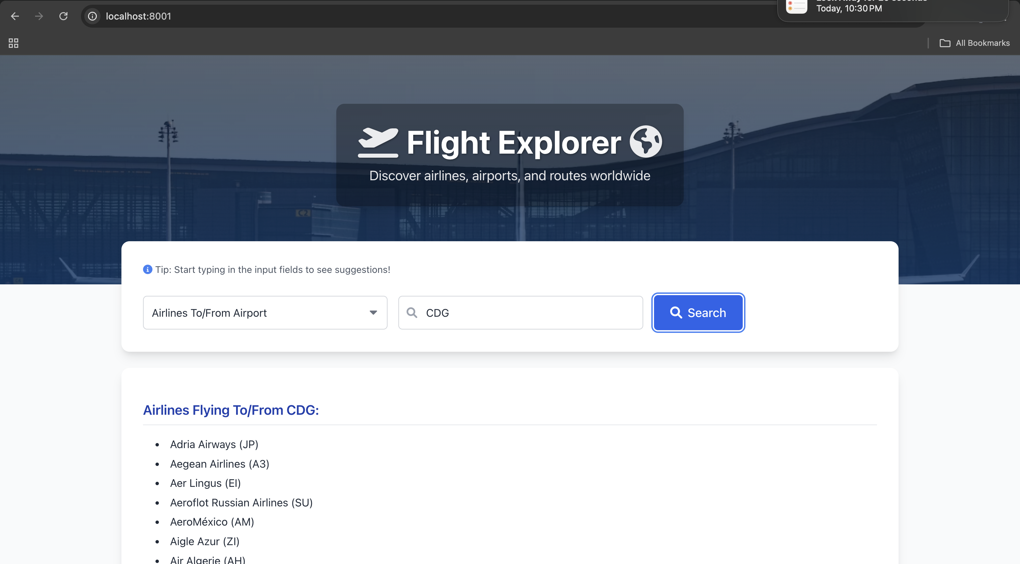
7. **Select Airport Pair ➔ View Airlines Flying Between**
   * **Test:** Select "Airlines Between Airports", enter **LAX** in the first input, **SYD** in the second. Click Search.
   * **Expected:** List "Airlines Flying Between LAX and SYD" (e.g., "Qantas (QF)"); Map shows LAX and SYD markers with connecting lines.
8. **Select Airport Pair ➔ View Distance Between**
   * **Test:** Select "Distance Between Airports", enter **LHR**  in the first input, **JFK**  in the second. Click Search.
   * **Expected:** "Distance Calculation:" showing details for LHR and JFK, the distance in km (~5540 km), and a list of airlines flying that route; Map shows LHR and JFK markers.

**4.3. Additional Features & Enhancements**

Beyond the mandatory requirements, several additional features were implemented:

1. **Interactive Map Visualization (Leaflet.js):** (Fulfills Extra Credit) Geographic display of airports/routes with markers, popups, lines, and auto-zoom.
2. **Autocomplete Suggestions:** Live suggestions for codes in input fields.
3. **Real-time Airport Weather:** Displays current day's High/Low temperatures for Airport Details search via Open-Meteo API.
4. **Airline Name Display:** Shows full airline names with IATA codes in results lists and tables.
5. **Dynamic UI Elements:** Adaptive placeholders, contextual result headings, user tips.
6. **Loading Indicators & Error Handling:** Visual feedback during searches and clear messages on errors.
7. **Professional UI Theme:** Modern look-and-feel using Tailwind CSS and custom styles (hero section, forms, tables, etc.).

**5. Technical Stack (Brief)**

* **Frontend:** HTML, CSS (Tailwind CSS, Custom CSS), Vanilla JavaScript, Axios, Leaflet.js
* **Backend:** Node.js, Express.js
* **Database:** PostgreSQL (configured via .env  file)
* **External APIs:** Open-Meteo (Weather)